R Project - Identifying individuals most likely to click an ad

Geoffrey Chege

2022-06-04

# 1. Introduction

## 1.1 Defining the question

* Determine which individuals are most likely to click on an ad using supervised learning prediction models.

## 1.2 The Context

* A Kenyan entrepreneur has created an online cryptography course and would want to advertise it on her blog.
* She currently targets audiences originating from various countries.
* In the past, she ran ads to advertise a related course on the same blog and collected data in the process.
* She would now like to employ my services as a Data Science Consultant to help her identify which individuals are most likely to click on her ads.

## 1.3 Metric for success

* Accuracy score of 85% and above.

## 1.4 Experimental Design Taken

* Installing packages and loading libraries needed
* Loading the data
* Data Cleaning
* Exploratory Data Analysis:
  + Univariate Analysis
  + Bivariate Analysis
* Modelling
* Predictions and evaluation of the model
* Conclusion

## 1.5 Appropriateness of the available data

* The columns in the dataset include:
  + Daily_Time_Spent_on_Site
  + Age
  + Area_Income
  + Daily_Internet_Usage
  + Ad_Topic_Line
  + City
  + Male
  + Country
  + Timestamp
  + Clicked_on_Ad

# 2. Installing and loading Necessary Packages

# 3. Loading the Data

ad <- read.csv("C:/Users/user/Downloads/advertising.csv") #Loading the dataset  
head(ad) #previewing the first 5 elements of the data

## Daily.Time.Spent.on.Site Age Area.Income Daily.Internet.Usage  
## 1 68.95 35 61833.90 256.09  
## 2 80.23 31 68441.85 193.77  
## 3 69.47 26 59785.94 236.50  
## 4 74.15 29 54806.18 245.89  
## 5 68.37 35 73889.99 225.58  
## 6 59.99 23 59761.56 226.74  
## Ad.Topic.Line City Male Country  
## 1 Cloned 5thgeneration orchestration Wrightburgh 0 Tunisia  
## 2 Monitored national standardization West Jodi 1 Nauru  
## 3 Organic bottom-line service-desk Davidton 0 San Marino  
## 4 Triple-buffered reciprocal time-frame West Terrifurt 1 Italy  
## 5 Robust logistical utilization South Manuel 0 Iceland  
## 6 Sharable client-driven software Jamieberg 1 Norway  
## Timestamp Clicked.on.Ad  
## 1 2016-03-27 00:53:11 0  
## 2 2016-04-04 01:39:02 0  
## 3 2016-03-13 20:35:42 0  
## 4 2016-01-10 02:31:19 0  
## 5 2016-06-03 03:36:18 0  
## 6 2016-05-19 14:30:17 0

# 4. Data Cleaning

## 4.1 Checking the attribute types

## Daily.Time.Spent.on.Site Age Area.Income   
## "numeric" "integer" "numeric"   
## Daily.Internet.Usage Ad.Topic.Line City   
## "numeric" "character" "character"   
## Male Country Timestamp   
## "integer" "character" "character"   
## Clicked.on.Ad   
## "integer"

* The attribute types in the data are: numeric, integer and character.

## 4.2 converting time variable from character to date and time (POSIXct) format

ad$Timestamp <- as.POSIXct(ad$Timestamp, "%Y-%m-%d %H:%M:%S",tz = "GMT")

## 4.3 Checking for duplicates

duplicates <- ad[duplicated(ad),] #storing duplicates in a table called "duplicates"  
duplicates #previewing the table

## [1] Daily.Time.Spent.on.Site Age Area.Income   
## [4] Daily.Internet.Usage Ad.Topic.Line City   
## [7] Male Country Timestamp   
## [10] Clicked.on.Ad   
## <0 rows> (or 0-length row.names)

* The duplicates table is empty. This means that there are no duplicates in the dataset.

## 4.4 checking for null values

colSums(is.na(ad)) #Checking the total number of null values in each column

## Daily.Time.Spent.on.Site Age Area.Income   
## 0 0 0   
## Daily.Internet.Usage Ad.Topic.Line City   
## 0 0 0   
## Male Country Timestamp   
## 0 0 0   
## Clicked.on.Ad   
## 0

* There are no null values in the dataset

## 4.5 checking column names

names(ad) #Displaying column names

## [1] "Daily.Time.Spent.on.Site" "Age"   
## [3] "Area.Income" "Daily.Internet.Usage"   
## [5] "Ad.Topic.Line" "City"   
## [7] "Male" "Country"   
## [9] "Timestamp" "Clicked.on.Ad"

* The data set has the above column names. Columns with more than one word have periods “.” separating the words. I will replace the periods “.” with underscores “_”

names(ad) <- gsub("[.]", "_", names(ad)) #Replacing "." with "_"

* The above code replaces the periods “.” with underscores “_“.

names(ad) #Displaying column names

## [1] "Daily_Time_Spent_on_Site" "Age"   
## [3] "Area_Income" "Daily_Internet_Usage"   
## [5] "Ad_Topic_Line" "City"   
## [7] "Male" "Country"   
## [9] "Timestamp" "Clicked_on_Ad"

## 4.6 Outliers

* I will use boxplots to check for outliers.

### Boxplot for “Area_Income”

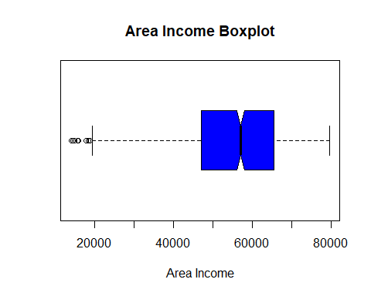

* There are few outliers in the “Area_Income” column. I will not remove them because they will be relevant in the analysis.

### Boxplot for “Age”

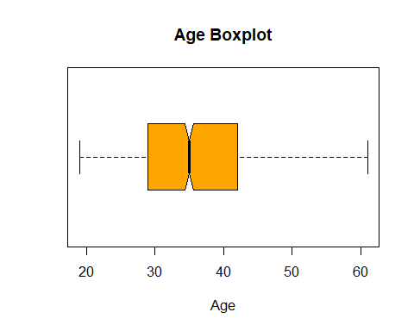

* There are no outliers in the “Age” column.

### Boxplot for “Daily_Time_Spent_on_Site”

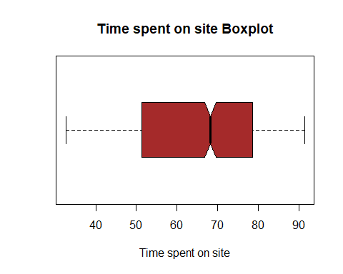

* There are no outliers in the “Time_Spent_on_Site” column.

### Boxplot for “Daily_Internet_Usage”

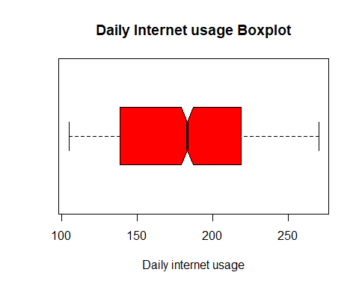

* There are no outliers in the “Daily_Internet_Usage” column.

# 5. Exploratory Data Analysis

## 5.1 Univariate Analysis

* Summary statistics of the dataset

summary(ad)

## Daily_Time_Spent_on_Site Age Area_Income Daily_Internet_Usage  
## Min. :32.60 Min. :19.00 Min. :13996 Min. :104.8   
## 1st Qu.:51.36 1st Qu.:29.00 1st Qu.:47032 1st Qu.:138.8   
## Median :68.22 Median :35.00 Median :57012 Median :183.1   
## Mean :65.00 Mean :36.01 Mean :55000 Mean :180.0   
## 3rd Qu.:78.55 3rd Qu.:42.00 3rd Qu.:65471 3rd Qu.:218.8   
## Max. :91.43 Max. :61.00 Max. :79485 Max. :270.0   
## Ad_Topic_Line City Male Country   
## Length:1000 Length:1000 Min. :0.000 Length:1000   
## Class :character Class :character 1st Qu.:0.000 Class :character   
## Mode :character Mode :character Median :0.000 Mode :character   
## Mean :0.481   
## 3rd Qu.:1.000   
## Max. :1.000   
## Timestamp Clicked_on_Ad  
## Min. :2016-01-01 02:52:10 Min. :0.0   
## 1st Qu.:2016-02-18 02:55:42 1st Qu.:0.0   
## Median :2016-04-07 17:27:29 Median :0.5   
## Mean :2016-04-10 10:34:06 Mean :0.5   
## 3rd Qu.:2016-05-31 03:18:14 3rd Qu.:1.0   
## Max. :2016-07-24 00:22:16 Max. :1.0

* Using “describe()” function to get range, skewness, kurtosis and standard deviation. The “summary()” function does not give us this information.

describe(ad)

## Warning in FUN(newX[, i], ...): no non-missing arguments to min; returning Inf

## Warning in FUN(newX[, i], ...): no non-missing arguments to max; returning -Inf

## vars n mean sd median trimmed mad  
## Daily_Time_Spent_on_Site 1 1000 65.00 15.85 68.22 65.74 17.92  
## Age 2 1000 36.01 8.79 35.00 35.51 8.90  
## Area_Income 3 1000 55000.00 13414.63 57012.30 56038.94 13316.62  
## Daily_Internet_Usage 4 1000 180.00 43.90 183.13 179.99 58.61  
## Ad_Topic_Line* 5 1000 500.50 288.82 500.50 500.50 370.65  
## City* 6 1000 487.32 279.31 485.50 487.51 356.57  
## Male 7 1000 0.48 0.50 0.00 0.48 0.00  
## Country* 8 1000 116.41 69.94 114.50 115.82 89.70  
## Timestamp 9 1000 NaN NA NA NaN NA  
## Clicked_on_Ad 10 1000 0.50 0.50 0.50 0.50 0.74  
## min max range skew kurtosis se  
## Daily_Time_Spent_on_Site 32.60 91.43 58.83 -0.37 -1.10 0.50  
## Age 19.00 61.00 42.00 0.48 -0.41 0.28  
## Area_Income 13996.50 79484.80 65488.30 -0.65 -0.11 424.21  
## Daily_Internet_Usage 104.78 269.96 165.18 -0.03 -1.28 1.39  
## Ad_Topic_Line* 1.00 1000.00 999.00 0.00 -1.20 9.13  
## City* 1.00 969.00 968.00 0.00 -1.19 8.83  
## Male 0.00 1.00 1.00 0.08 -2.00 0.02  
## Country* 1.00 237.00 236.00 0.08 -1.23 2.21  
## Timestamp Inf -Inf -Inf NA NA NA  
## Clicked_on_Ad 0.00 1.00 1.00 0.00 -2.00 0.02

From the “summary()” and “describe()” functions, the following measures of central tendency can be gathered:

### Daily_Time_Spent_on_Site:

* mean: 65
* median: 68.22
* maximum: 91.43
* minimum: 32.60
* range: 58.83
* skew: -0.37
* kurtosis: -1.10

### Age:

* mean: 36.01
* median: 35
* maximum: 61
* minimum: 19
* range: 42
* skew: 0.48
* kurtosis: -0.41

### Area Income:

* mean: 55,000
* median: 57,012
* maximum: 79,484.8
* minimum: 13,996.5
* range: 65,488.30
* skew: -0.65
* kurtosis: -0.11

### Daily_Internet_Usage:

* mean: 180
* median: 183.1
* maximum: 269.96
* minimum: 104.78
* range: 165.18
* skew: -0.03
* kurtosis: -1.28

### Mode

* A function to determine the mode:

mode <- function(v){  
 uniq <- unique(v)  
 uniq[which.max(tabulate(match(v,uniq)))]  
}

The most recurrent Ad Topic Line:

## [1] "Cloned 5thgeneration orchestration"

The most recurrent City:

## [1] "Lisamouth"

The most recurrent Country:

## [1] "Czech Republic"

* Checking the modal age using a barplot:

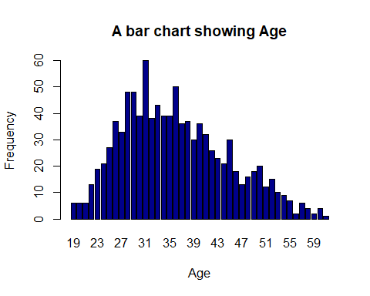

* From the plot, the modal age is 31.
* Checking the distribution in terms of gender where 1 is Male and 0 is Female:

## gender  
## 0 1   
## 519 481

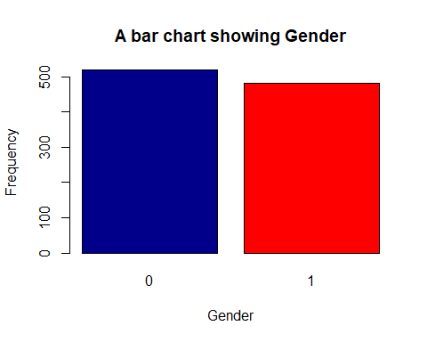

From this, there are More women than men, making female the modal gender.

## 5.2 Bivariate Analysis

### Scatterplots

# scatterplot  
plot((ad$Daily_Time_Spent_on_Site), (ad$Age),  
 main = "A scatterplot of Time Spent on site against age",  
 xlab = 'Time spent',  
 ylab = 'Age')

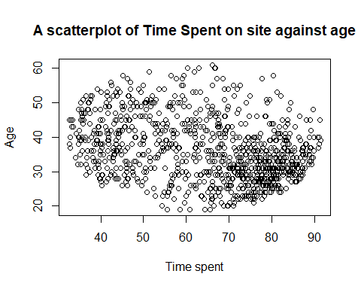

# scatterplot of Time on site vs income  
plot((ad$Daily_Time_Spent_on_Site), (ad$Area_Income),  
 main = "A scatterplot of Time Spent on site against income",  
 xlab = 'Time Spent on Site',  
 ylab = 'Income')

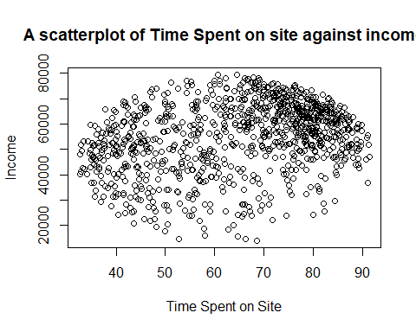

# scatterplot of Time on site vs Internet usage  
plot((ad$Daily_Time_Spent_on_Site), (ad$Daily_Internet_Usage),  
 main = "A scatterplot of Time Spent on site against Daily Internet Usage",  
 xlab = 'Time Spent on Site',  
 ylab = 'Daily Internet Usage')

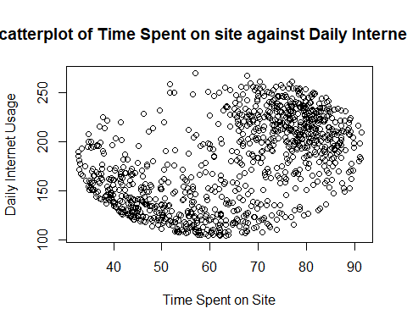

### Heatmap

# Heat map  
# Checking the relationship between the variables  
# Using Numeric variables only  
numeric_tbl <- ad %>%  
 select_if(is.numeric) %>%  
 select(Daily_Time_Spent_on_Site, Age, Area_Income,Daily_Internet_Usage)  
# Calculate the correlations  
corr <- cor(numeric_tbl, use = "complete.obs")  
ggcorrplot(round(corr, 2),  
 type = "full", lab = T)

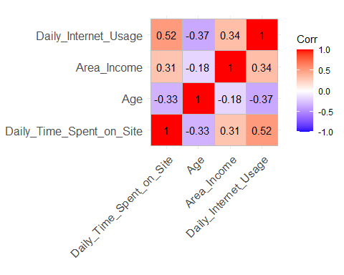

### Analysis of those who clicked on ads:

# Analysis of people who click on the ads  
ad_click <- ad[which(ad$Clicked_on_Ad == 1),] # Creating a new dataset that only has those who clicked on an ad

* Most popular age group of people clicking on ads:

# Most popular age group of people clicking on ads  
hist((ad_click$Age),  
 main = "Histogram of Age of those who click ads",  
 xlab = 'Age',  
 ylab = 'Frequency',  
 col = "blue")

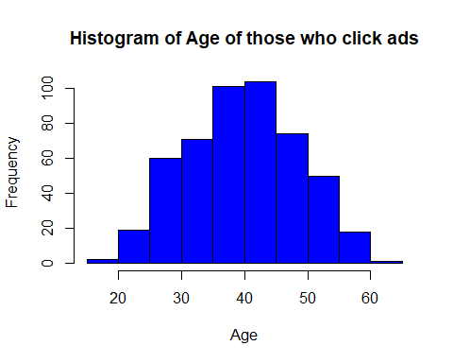

* 40 - 45 year olds click on the most ads.

### Plotting to visualize the gender distribution:

gender2 <- (ad_click$Male)  
gender2.frequency <- table(gender2)  
gender2.frequency

## gender2  
## 0 1   
## 269 231

# plotting to visualize the gender distribution  
barplot(gender2.frequency,  
 main="A bar chart showing Gender of those who clicked",  
 xlab="Gender(0 = Female, 1 = Male)",  
 ylab = "Frequency",  
 col=c("darkblue","red"),  
 )

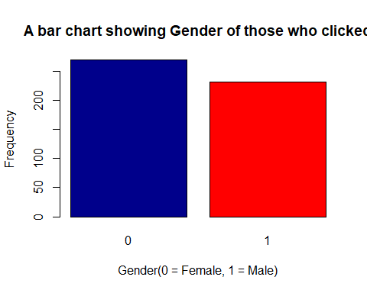

* Females clicked more ads than males.

### Scatterplots of those who clicked:

# scatterplot  
plot((ad_click$Daily_Time_Spent_on_Site), (ad_click$Age),  
 main = "A scatterplot of Time Spent on site and clicked ad against age",  
 xlab = 'Time spent',  
 ylab = 'Age')

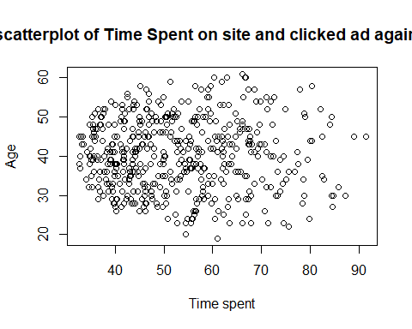

# scatterplot of Time on site vs income  
plot((ad_click$Daily_Time_Spent_on_Site), (ad_click$Area_Income),  
 main = "A scatterplot of Time Spent on site and ad clicked against income",  
 xlab = 'Time Spent on Site',  
 ylab = 'Income')

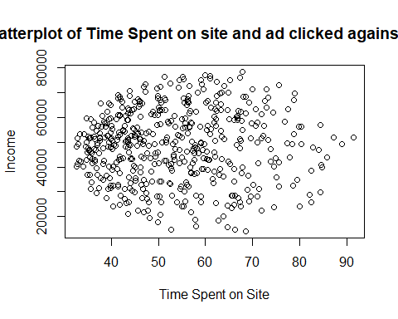

# scatterplot of Time on site vs Internet usage  
plot((ad_click$Daily_Time_Spent_on_Site), (ad_click$Daily_Internet_Usage),  
 main = "A scatterplot of Time Spent on site and ad clicked against Daily Internet Usage",  
 xlab = 'Time Spent on Site',  
 ylab = 'Daily Internet Usage')

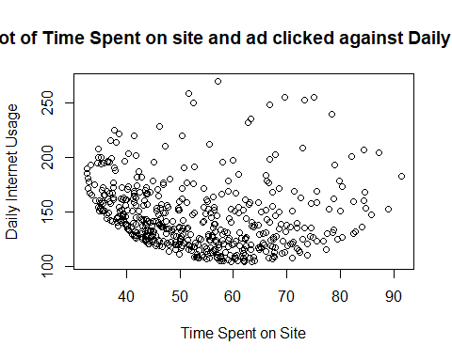

# Heat map  
# Checking the relationship between the variables  
  
# Using Numeric variables only  
numeric_tbl <- ad_click %>%  
 select_if(is.numeric) %>%  
 select(Daily_Time_Spent_on_Site, Age, Area_Income,Daily_Internet_Usage)  
  
# Calculate the correlations  
corr <- cor(numeric_tbl, use = "complete.obs")  
ggcorrplot(round(corr, 2),  
 type = "full", lab = T)

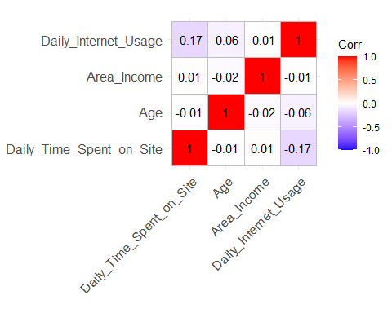

* There is low correlation between the numerical variables.
* The country with the most ad clicks:

mode(ad_click$Country)

## [1] "Australia"

* The income that clicks most:

mode(ad_click$Area_Income)

## [1] 24593.33

* Ad title that garners most clicks:

## [1] "Reactive local challenge"

* All the data profiling statistics will be organized into the report below

create_report(ad)

##   
##   
## processing file: report.rmd

## | | | 0% | |.. | 2%  
## inline R code fragments  
##   
## | |... | 5%  
## label: global_options (with options)   
## List of 1  
## $ include: logi FALSE  
##   
## | |..... | 7%  
## ordinary text without R code  
##   
## | |....... | 10%  
## label: introduce  
## | |........ | 12%  
## ordinary text without R code  
##   
## | |.......... | 14%  
## label: plot_intro

## | |............ | 17%  
## ordinary text without R code  
##   
## | |............. | 19%  
## label: data_structure  
## | |............... | 21%  
## ordinary text without R code  
##   
## | |................. | 24%  
## label: missing_profile

## | |.................. | 26%  
## ordinary text without R code  
##   
## | |.................... | 29%  
## label: univariate_distribution_header  
## | |...................... | 31%  
## ordinary text without R code  
##   
## | |....................... | 33%  
## label: plot_histogram

## | |......................... | 36%  
## ordinary text without R code  
##   
## | |........................... | 38%  
## label: plot_density  
## | |............................ | 40%  
## ordinary text without R code  
##   
## | |.............................. | 43%  
## label: plot_frequency_bar

## | |................................ | 45%  
## ordinary text without R code  
##   
## | |................................. | 48%  
## label: plot_response_bar  
## | |................................... | 50%  
## ordinary text without R code  
##   
## | |..................................... | 52%  
## label: plot_with_bar  
## | |...................................... | 55%  
## ordinary text without R code  
##   
## | |........................................ | 57%  
## label: plot_normal_qq

## | |.......................................... | 60%  
## ordinary text without R code  
##   
## | |........................................... | 62%  
## label: plot_response_qq  
## | |............................................. | 64%  
## ordinary text without R code  
##   
## | |............................................... | 67%  
## label: plot_by_qq  
## | |................................................ | 69%  
## ordinary text without R code  
##   
## | |.................................................. | 71%  
## label: correlation_analysis

## | |.................................................... | 74%  
## ordinary text without R code  
##   
## | |..................................................... | 76%  
## label: principal_component_analysis

## | |....................................................... | 79%  
## ordinary text without R code  
##   
## | |......................................................... | 81%  
## label: bivariate_distribution_header  
## | |.......................................................... | 83%  
## ordinary text without R code  
##   
## | |............................................................ | 86%  
## label: plot_response_boxplot  
## | |.............................................................. | 88%  
## ordinary text without R code  
##   
## | |............................................................... | 90%  
## label: plot_by_boxplot  
## | |................................................................. | 93%  
## ordinary text without R code  
##   
## | |................................................................... | 95%  
## label: plot_response_scatterplot  
## | |.................................................................... | 98%  
## ordinary text without R code  
##   
## | |......................................................................| 100%  
## label: plot_by_scatterplot

## output file: C:/Users/user/Documents/Geoffrey Chege Moringa IP W12/report.knit.md

## "C:/Program Files/RStudio/bin/quarto/bin/pandoc" +RTS -K512m -RTS "C:/Users/user/Documents/Geoffrey Chege Moringa IP W12/report.knit.md" --to html4 --from markdown+autolink_bare_uris+tex_math_single_backslash --output pandoc2d807e3d317e.html --lua-filter "C:\Users\user\Documents\R\win-library\4.1\rmarkdown\rmarkdown\lua\pagebreak.lua" --lua-filter "C:\Users\user\Documents\R\win-library\4.1\rmarkdown\rmarkdown\lua\latex-div.lua" --self-contained --variable bs3=TRUE --standalone --section-divs --table-of-contents --toc-depth 6 --template "C:\Users\user\Documents\R\win-library\4.1\rmarkdown\rmd\h\default.html" --no-highlight --variable highlightjs=1 --variable theme=yeti --mathjax --variable "mathjax-url=https://mathjax.rstudio.com/latest/MathJax.js?config=TeX-AMS-MML_HTMLorMML" --include-in-header "C:\Users\user\AppData\Local\Temp\RtmpikREnW\rmarkdown-str2d802b125b3f.html"

##   
## Output created: report.html

* A link to the report: “<https://github.com/Geoffrey-Chege/Supervised-and-Unsupervised-Learning/blob/main/Ad%20Clicks/report.html>”

# 6. Modelling

# Heat map  
# Checking the relationship between the variables  
  
# Using Numeric variables only  
numeric_tbl2 <- ad %>%  
 select_if(is.numeric) %>%  
 select(Daily_Time_Spent_on_Site, Age, Area_Income,Daily_Internet_Usage, Clicked_on_Ad)  
  
# Calculate the correlations  
corr <- cor(numeric_tbl2, use = "complete.obs")  
ggcorrplot(round(corr, 2),  
 type = "full", lab = T)

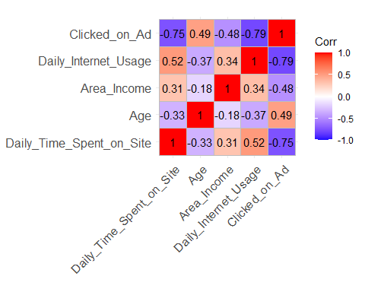

1. Daily_Time_Spent_on_Site and Clicked_on_Ad variables are strongly inversely related with a correlation of -0.75.
2. Daily_Internet_Usage and Clicked_on_Ad are strongly variable are strongly inversely related with a correlation of - 0.79.
3. Daily_Time_Spent_on_Site and Daily_Internet_Usage variables are positively related with 0.52. correlation.
4. Age and Daily_Internet_Usage variables are positively related with 0.49 correlation.

Clicked_on_Ad is the target variable so I will get correlation without it included.

# Heat map  
# Checking the relationship between the variables  
  
# Using Numeric variables only  
numeric_tbl3 <- ad %>%  
 select_if(is.numeric) %>%  
 select(Daily_Time_Spent_on_Site, Age, Area_Income,Daily_Internet_Usage)  
  
# Calculating the correlations  
corr <- cor(numeric_tbl3, use = "complete.obs")  
ggcorrplot(round(corr, 2),  
 type = "full", lab = T)



* There are no highly correlated numeric independent variables, so I will use them all in analysis.

## Normalizing the independent variables to ensure all the data is on the same scale

# Normalizing the dataset  
normalize <- function(x){  
 return ((x-min(x)) / (max(x)-min(x)))  
}  
ad$Daily_Time_Spent_on_Site <- normalize(ad$Daily_Time_Spent_on_Site)  
ad$Age <- normalize(ad$Age)  
ad$Area_Income <- normalize(ad$Area_Income)  
ad$Male <- normalize(ad$Male)  
  
#previewing normalized dataset  
head(ad)

## Daily_Time_Spent_on_Site Age Area_Income Daily_Internet_Usage  
## 1 0.6178820 0.3809524 0.7304725 256.09  
## 2 0.8096209 0.2857143 0.8313752 193.77  
## 3 0.6267211 0.1666667 0.6992003 236.50  
## 4 0.7062723 0.2380952 0.6231599 245.89  
## 5 0.6080231 0.3809524 0.9145678 225.58  
## 6 0.4655788 0.0952381 0.6988280 226.74  
## Ad_Topic_Line City Male Country  
## 1 Cloned 5thgeneration orchestration Wrightburgh 0 Tunisia  
## 2 Monitored national standardization West Jodi 1 Nauru  
## 3 Organic bottom-line service-desk Davidton 0 San Marino  
## 4 Triple-buffered reciprocal time-frame West Terrifurt 1 Italy  
## 5 Robust logistical utilization South Manuel 0 Iceland  
## 6 Sharable client-driven software Jamieberg 1 Norway  
## Timestamp Clicked_on_Ad  
## 1 2016-03-27 00:53:11 0  
## 2 2016-04-04 01:39:02 0  
## 3 2016-03-13 20:35:42 0  
## 4 2016-01-10 02:31:19 0  
## 5 2016-06-03 03:36:18 0  
## 6 2016-05-19 14:30:17 0

* The dataset is on the same scale.

## Splitting Data into Training and Testing Sets

# splitting the data into training and testing sets  
# I will split it 70:30  
intrain <- createDataPartition(y = ad$Clicked_on_Ad, p = 0.7, list = FALSE)  
training <- ad[intrain,]  
testing <- ad[-intrain,]

# checking the dimensions of our training and testing sets  
dim(training)

## [1] 700 10

dim(testing)

## [1] 300 10

* 700 of data will be used for training while 300 will be for testing.

# checking the dimensions of our split  
prop.table(table(ad$Clicked_on_Ad)) * 100

##   
## 0 1   
## 50 50

prop.table(table(training$Clicked_on_Ad)) * 100

##   
## 0 1   
## 50 50

prop.table(table(testing$Clicked_on_Ad)) * 100

##   
## 0 1   
## 50 50

* The target data is equal in the data,training set and test set.

## Decision Tree Classifier

# Specifying target and predictor variables  
m <- rpart(Clicked_on_Ad ~ . ,  
 data = numeric_tbl2,  
 method = "class")

# Plotting model  
rpart.plot(m)

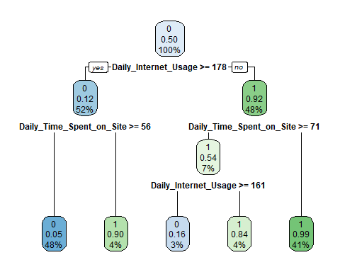

# Making predictions  
p <- predict(m, numeric_tbl2, type ="class")  
  
# Printing the confusion matrix  
table(p, numeric_tbl2$Clicked_on_Ad)

##   
## p 0 1  
## 0 485 28  
## 1 15 472

* The model correctly classified 485 did not clicks as ‘0’ and 472 clicks as ‘1’ . However, it also incorrectly classified 28 did not clicks as ‘1’(clicked) and 15 clicks as ‘0’(did not click).

# Printing the Accuracy  
(mean(numeric_tbl2$Clicked_on_Ad == p))*100

## [1] 95.7

* The model has an accuracy of 95.7%
* This is a good model for making predictions

# 7. Conclusions

* Decision Tree gives an accuracy of 95.7%
* The females have the majority site visits but they don’t click on the ad.
* The minimum age of the participant was 19 years old while the oldest was 60 years old.
* The minimum daily time spent on the site was 32 minutes while the maximum time spent was 91 minutes.
* The youth have most site visits as compared to the teenagers and older people.

# 8. Recommendations

* Appropriate content targeting different age groups should be uploaded when it comes to the ads. This will lead to an increase in the number of clicks on ads.
* There should be more locally targeted ads, seeing as the key word ‘local’ prompted more clicks.